*FOR IMMEDIATE RELEASE*

**The Law of Presidential Impeachment**

***A Guide for the Engaged Citizen***

**by Michael J. Gerhardt**

**NYU Press | Hardcover | 9781479824694 | Law | 200 Pages | 5.00 x 8.00 | $24.95 | On Sale January 9, 2024**

“A well-informed look at a crucial safeguard against the abuse of power.”

**~*Kirkus Reviews***

“An accessible and insightful tour through American presidential impeachments by the foremost scholar in the field. On a topic that stirs up political passions, Michael Gerhardt provides sober judgement.” *~***Keith Whittington, William Nelson Cromwell Professor of Politics, Princeton University**

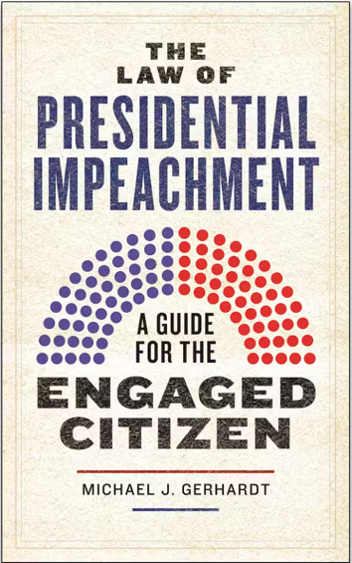**A clear and comprehensive overview of presidential impeachment from a leading expert in the field.**   
  
As a result of Donald Trump’s presidency, impeachment was once again thrust into the spotlight of American political discussion. However, its history goes back to the very founding of the nation, when American colonists, remembering their grievances against their former king, entrenched the process in their new Constitution.  
  
*The Law of Presidential Impeachment*breaks down both the law and politics of this process, providing a comprehensive, nonpartisan, and up-to-date explanation of the Constitution’s various mechanisms for holding presidents accountable for their misdeeds. Based on a lifetime of scholarly research, as well as unique experience as a witness and consultant in the impeachment trials of Bill Clinton and Donald Trump, Michael J. Gerhardt’s new book takes the reader back to the basics of presidential impeachments. Rather than provide reasons for or against impeaching particular presidents, he explains the law and procedures that govern impeachment, examining a number of significant, yet under-explored, issues and themes. Gerhardt offers new perspectives on the subject, arguing that it cannot be properly understood in a vacuum, but must instead be viewed in the context of its coordination with such other mechanisms as criminal prosecutions, censure, elections, congressional oversight, and the Fourteenth and Twenty-Fifth Amendments.  
  
*The Law of Presidential Impeachment* will be an invaluable, accessible guide for future generations, giving them a succinct yet remarkably nuanced understanding of this core aspect of our executive branch and overarching governmental system.

*****About the Author:* Michael J. Gerhardt** is Burton Craige Distinguished Professor of Jurisprudence at the University of North Carolina Law School and author of eight books, including *The Forgotten Presidents: Their Untold Constitutional Legacy*, which *The Financial Time*s selected as one of the best non-fiction books of 2013. He has written more than a hundred law review articles and dozens of op-eds in the nation’s leading news publications, including *SCOTUSblog*, *The New York Times*, and *Washington Post.*

Gerhardt’s extensive public service has included his testifying more than 20 times before Congress, including as the only joint witness in the Clinton impeachment proceedings in the House; speaking behind closed doors to the entire House of Representatives about the history of impeachment in 1998; serving as special counsel to the Senate Judiciary Committee for eight of the nine sitting Supreme Court justices; and as one of only two legal scholars to testify in three different presidential impeachment hearings (Clinton in 1998, Trump in 2019, and Biden in 2023). During the Clinton and first Trump impeachment proceedings, Gerhardt served as an impeachment expert for CNN. In the second impeachment trial of President Trump, he was an expert commentator for CNN, Fox, and MSNBC and served as special counsel to the Presiding Officer, Senator Patrick Leahy.

***Praise for The Law of Presidential Impeachment:***

“A sharp, informed treatment of impeachment, for experts and newcomers alike, incorporating what has been learned as a result of recent events, and with a detailed discussion of the Trump impeachment and associated events.”

*~***Cass R. Sunstein, Robert Walmsley University Professor, Harvard University**

“Gerhardt, a nationally recognized expert on this topic, is the exact scholar needed to write this concise and accessible guide to all things impeachment. This will certainly be the new definitive text on the subject.”

*~***Lori Cox Han, Professor of Political Science, Chapman University**

###